IRVINE & TROON CANCER CARE  Charity No. SC 014645 | 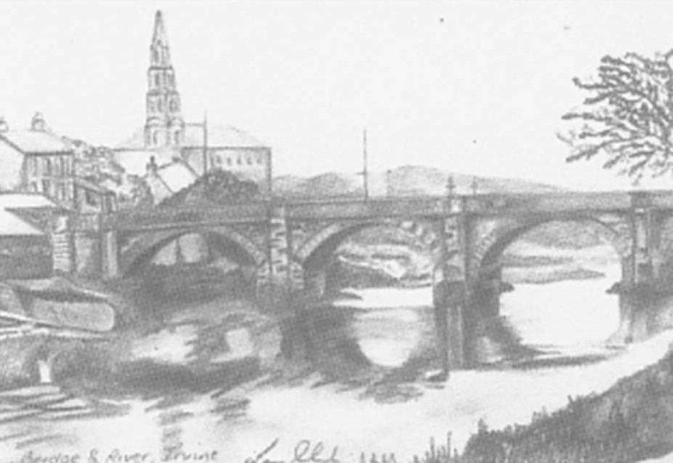

I would like to make a donation of: £ . pence

Title: Mr Mrs Ms Miss Dr Other:
(Please tick)

Donor Name:

Address:

Postcode:


If you are a Taxpayer, completion of the Gift Aid Declaration increases your donation by 0.25p per pound. The Government is trying to make giving to charity so much easier, and we hope that all our supporters who are taxpayers will be happy to help us in this way. It makes a substantial difference and this increases with every eligible donor.

Thank you all.

Please tick
I am a taxpayer and would like this donation and all subsequent donations to Irvine & Troon Cancer Care to be treated as Gift Aid, and for the charity to benefit by reclaiming the tax.

Signature: Date:

(cheque or postal order donations welcome).
Cheques should be crossed and made payable to “Irvine & Troon Cancer Care”.

Post completed form and cheque / postal order to:

Irvine & Troon Cancer Care
Heathfield House
5 Kilwinning Road
IRVINE KA12 8RR

